**DATABASE PROJECT**

**Hospital Management System**

Date: 04/12/18

Normalization:

All the tables are in 3nf since the schema was designed before the normalization chapter was started in the class. The reference schema for the construction of our schema was the employee and project schema, that is already normalized, thoroughly discussed in the text book.

ERD:

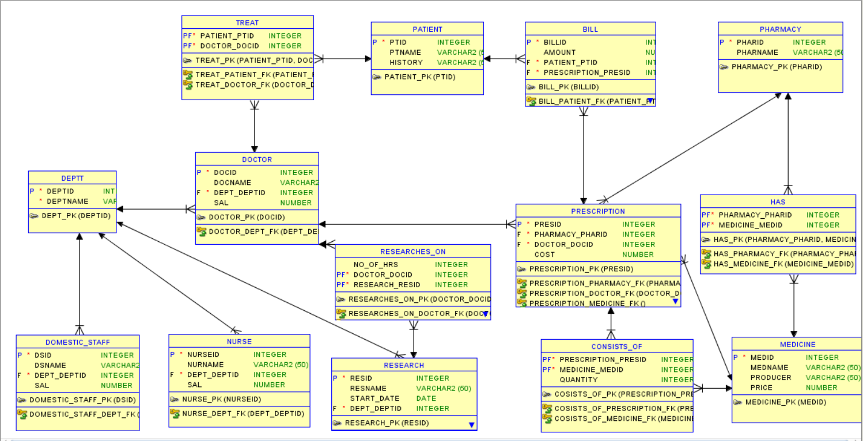

Constraints:

All the tables have primary key and foreign key relationships; individually mentioned at the end of ddl file.

The ‘doctors’, ‘domestic staff’, and ‘nurses’ belong to a particular department of hospital. Research work is also carried under the supervision department. The relation ‘researches_on’ make use doctor and research as foreign keys.

The ‘has’ relation comprises of medicines each pharmacy possesses. The ‘consists_of’ relation tells the number of medicines and their type in prescription. The ‘prescription’ maintains the records of the pharmacy that has generated it and the doctor that has prescribed it. The ‘bill’ relation consists of the prescription and its cost along with patient that has to pay it.

Limitations:

The 2nd paragraph mentions a lot of foreign key constraints interdependent on each other. A problem may arise when updating the initial or parent tuple in the table ‘pharmacy’ or ‘medicine’. Solution to this problem is by altering all the constraints to provide a cascading effect.